WORKSHEET-3

**SQL**

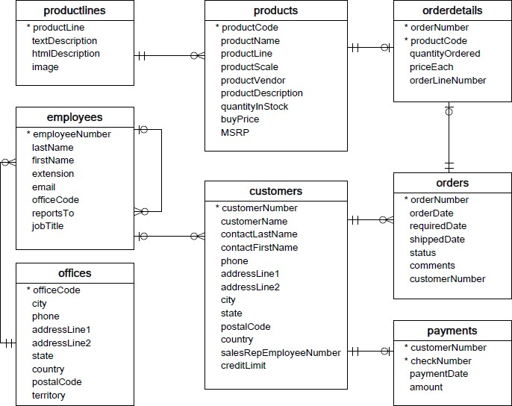**Refer the following ERD and answer all the questions in this worksheet. You have to write the queries using mysql for the required Operation.**

* **Customers**: stores customer’s data.
* **Products**: stores a list of scale model cars.
* **Product Lines**: stores a list of product line categories.
* **Orders**: stores sales orders placed by customers.
* **Order Details**: stores sales order line items for each sales order.
* **Payments**: stores payments made by customers based on their accounts.
* **Employees**: stores all employee information as well as the organization structure such as who reports to whom.
* **Offices**: stores sales office data.

1. Write SQL query to create table Customers.

**Answer:**

create table customers (customerNumber int AUTO_INCREMENT PRIMARY KEY,

customerName varchar(50),

contactLastName varchar(50),

contactFirstName varchar(50),

phone int(50),

addressLine1 varchar(100),

addressLine2 varchar(100),

city varchar(50),

state varchar(50),

postalCode int(100),

country varchar(100),

salesRepEmployeeNumber int(100),

creditLimit int);

2. Write SQL query to create table Orders.

**Answer:**

create table orders(orderNumber int AUTO_INCREMENT PRIMARY KEY,

orderDate varchar(100),

requiredDate varchar(100),

shippedDate varchar(100),

status varchar(100),

comments varchar(100),

FOREIGN KEY (customerNumber) REFERENCES customers(customerNumber));

3. Write SQL query to show all the columns data from the Orders Table.

**Answer:** select * from orders;

4. Write SQL query to show all the comments from the Orders Table.

**Answer:** select comments from orders;

5. Write a SQL query to show orderDate and Total number of orders placed on that date, from orders table.

**Answer:** select orderDate, count(orderNumber) as totalorders from orders group by orderDate;

6. Write a SQL query to show employeNumber, lastName, firstName of all the employees from employees table.

**Answer:** select employeeNumber, lastName, firstName from employees;

7. Write a SQL query to show all orderNumber, customerName of the person who placed the respective order.

**Answer:** select o.orderNumber,c.customername from customers c inner join orders o on o.customernumber=c.customernumber;

8. Write a SQL query to show name of all the customers in one column and salerepemployee name in another column.

**Answer:** select customername,SalesRepEmployeeNumber from customers;

9. Write a SQL query to show Date in one column and total payment amount of the payments made on that date from the payments table.

**Answer:** select paymentDate,SUM(amount) as total_payment from payments group by paymentDate;

10. Write a SQL query to show all the products productName, MSRP, productDescription from the products table.

**Answer:** select productName, MSRP, productDescription from products;

11. Write a SQL query to print the productName, productDescription of the most ordered product.

**Answer:** select p.productName,p.productDescription from products p inner join orderdetails o on p.productCode=o.productCode where o.quantityordered=(select max(o.quantityOrdered) from orderdetails o);

12. Write a SQL query to print the city name where maximum number of orders were placed.

**Answer:** select c.city from customers c inner join orders o on c.customerNumber=o.customerNumber where o.orderdate=(select max(orderDate) from orders o);

13. Write a SQL query to get the name of the state having maximum number of customers.

**Answer:** select state,count(state) as total_state from customers group by state order by total_state desc limit 1;

14. Write a SQL query to print the employee number in one column and Full name of the employee in the second column for all the employees.

**Answer:** select employeeNumber ,concat(firstname,' ',lastname) as fullname from employees;

15. Write a SQL query to print the orderNumber, customer Name and total amount paid by the customer for that order (quantityOrdered × priceEach).**Answer:** select od.ordernumber,c.customerName,od.quantityordered*od.priceeach as total_amount_paid from orders o inner join customers c on o.customernumber=c.customernumber inner join orderdetails od on od.ordernumber=o.ordernumber;